**Linear Functions 1 7/6**

Directions: Tell whether each equation is linear. If so, write the equation in standard form, give the values of A, B, and C, and graph using the 2 intercepts.

Example: y = x - 1

Linear

-x + y = -1

A=-1, B=1, C=-1

X-intercept: -x = -1, x = 1

Y-intercept: y= -1

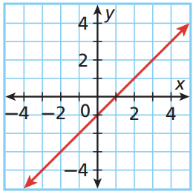

1) 2x - 8y = 16 2) y = 4x + 2 3) 2x = y/3 - 4

4) 4/x = y 5) (x + 4)/2 = (y - 4)/4 6) x=7

7) xy = 6 8) 3x - 5 + y = 2y - 4 9) y = -x + 2

10) 5x = 2y - 3 11) 2y = -6 12) y = √x

13) One inch is equal to approximately 2.5 cm. Let x represent inches and y represent centimeters. Write an equation in standard form relating x and y. Give the values of A, B, and C.